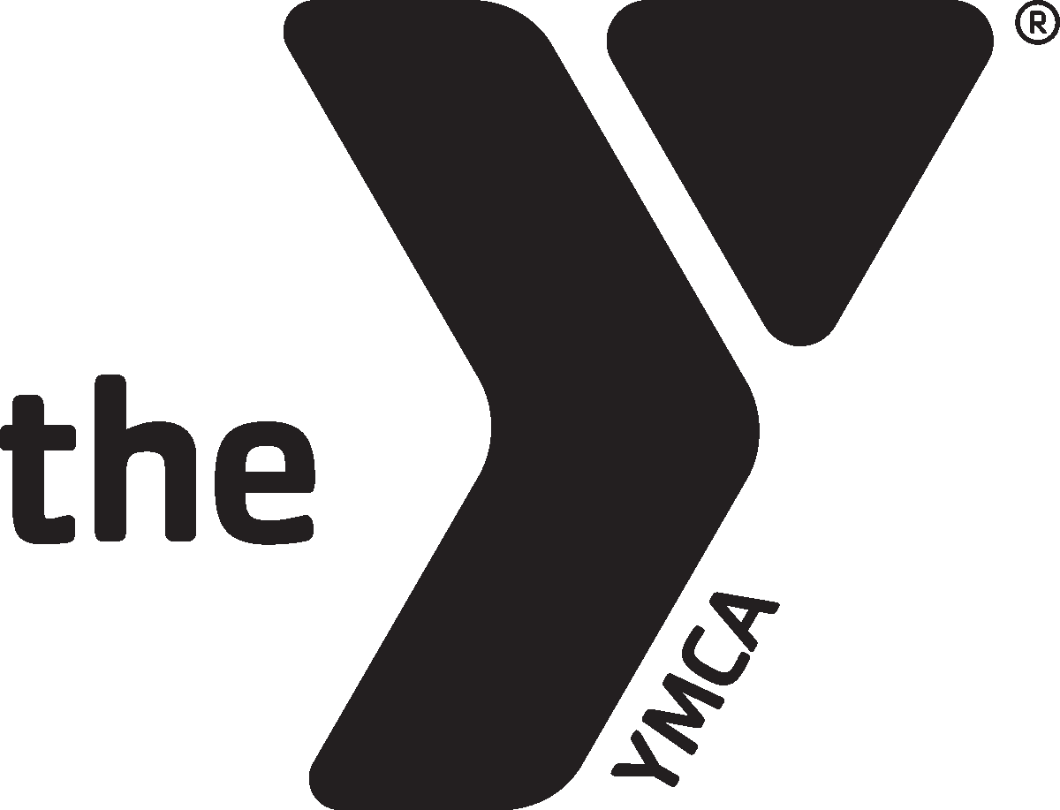
YMCA of the Chippewa Valley
REVISED
03/12/2020
Eau Claire Branch Large Pool Schedule
February 2 – March 21, 2020
March 16 – 20 from 5:00 – 9:30 PM Large Lifeguard Course in Pool

(#) indicates number of lanes available

Sunday | Monday |  | Tuesday |  | Wednesday | Thursday |  | Friday | Saturday
 | 5:00 – 5:45 AM  Lap (6) |  |  |  | 5:00 – 7:00 AM  Lap (6) | 5:00 – 5:45 AM  Lap (6) |  | 5:00 – 7:00 AM  Lap (6)
 | 5:45 – 7:00 AM  Tri/Lap League (3)  Lap (3) |  |  |  |  | 5:45 – 7:00 AM  Tri/Lap League (3)  Lap (3) |  |  | 6:00 –  10:00 AM  Lap (6)
7:00 – 7:30 AM
Lap (6)
7:30 – 8:00 AM
Lap (4) Water Walking (2)
 | 8:00 – 8:30 AM  Lap (2)  8:00 – 9:00 AM  Hydro Aerobics  8:30 – 9:30 AM  40 & Over Rec Swim  9:00 – 10:00 AM  Deep Water  Rec Swim  9:15 – 10:00 AM  Joint Efforts | 8:00 – 8:30 AM  Lap (2)  8:00 – 9:00 AM  Hydro Aerobics  8:30 – 9:30 AM  Mayo PT (2)  8:30 – 9:30 AM  Marshfield PT (2)  9:30 – 10:30 AM  40 & Over Rec Swim  9:00 – 10:00 AM  Deep Water  Rec Swim  9:15 – 10:00 AM  Joint Efforts |  |  | 8:00 – 8:30 AM  Lap (2)  8:00 – 9:00 AM  Hydro Aerobics  8:30 – 9:30 AM  40 & Over Rec. swim  9:00 – 10:00 AM  Deep Water Rec. Swim  9:15 – 10:00 AM  Joint Efforts |  |  | 8:00 – 8:30 AM  Lap (1)  8:00 – 9:00 AM  Hydro Aerobics  8:30 – 9:30 AM  40 & Over  Rec. swim  9:00 – 10:00 AM  Deep Water  Rec. Swim  9:15 – 10:00 AM  Joint Efforts
11:00 AM – 1:00 PM  Lap (6) | 10:00 – 11:15 AM  Open (3)  Lap (3) | 10:00 – 11:30 AM  Open (2)  Lap (2)  Marshfield (2) |  |  | 10:00 – 11:15AM  Open (3)  Lap (3) |  |  |  | 10:00 AM –  7:45 PM  Open (4)  Lap (2)
1:00 – 3:00 PM  Open (4)  Lap (2) | 11:15 AM – 1:00 PM  Lap (6) | 11:30 AM – 1:00 PM  Lap (6) |  | 11:15 AM – 1:00 PM  Lap (6)
 | 1:00 – 4:20 PM  Open (3)  Lap (3) |  |  |  |  |  | 1:00 – 2:00 PM  Open (3)  Lap (3) | 1:00 – 4:20 PM  Open (3)  Lap (3)
2:00 – 4:15 PM
Lap (2)
*MAYO PT*
2:15 – 4:15 PM (4)
3:15 – 6:55 PM  Lessons (6) | 4:30 – 6:40 PM  Lessons (6) | 4:30 – 5:30 PM  Open (3)  Lap (3) |  |  | 4:30 – 6:40 PM  Lessons (6) |  | 4:30 – 5:30 PM  Open (3)  Lap (3)
7:00 – 7:45 PM  Open (4)  Lap (2) |  | 5:45 – 7:25 PM  Lessons (6) |  |  |  |  | 5:45 – 7:15 PM  Lessons (6) | 6:00 – 9:30 PM  Open (4)  Lap (2)  6:30 – 8 PM  Flick & Float  02/14  **Extra 15-20**
 | 6:45 – 9:00 PM  Open (2)  Lap (2)  7:30 – 8:30 PM  Aqua Fit (2) | 7:30 – 9:00 PM  Open (4)  Lap (2) |  |  | 6:45 – 9:00 PM  Open (4)  Lap (2) |  | 7:20 – 9:00 AM  Open (4)  Lap (2)
9:00 – 9:30 PM
Lap (6)

REVISED
03/12/2020
YMCA of the Chippewa Valley
Eau Claire Branch Small Pool Schedule
February 2 – March 21, 2020

Sunday | Monday | Tuesday | Wednesday |  | Thursday |  | Friday |  | Saturday
11:00 AM –  3:00 PM  Open | 10:00 – 11:15 AM  Open | 9:00 – 10:00 AM  Child Care Lessons | 10:00 – 11:15 AM  Open |  |  | 9:00 – 10:00 AM  Child Care Lessons |  | 10:00 – 11:15 AM  Open | 10:00 AM –  7:45 PM  Open
 | 1:00- 4:20 PM  Open |  |  |  |  |  |  | 1:00 – 4:30 PM  Open
3:15 – 6:55 PM
Lessons
7:00 – 7:45 PM  Open | 4:30 – 6:40 PM  Lessons | 4:30 – 5:45 PM  Open |  | 4:30 – 6:40 PM  Lessons |  | 4:30 – 5:45 PM  Open
 |  | 6:00 – 7:25 PM  Lessons |  |  |  | 6:00 – 7:15 PM  Lessons |  | 6:15 – 9:30 PM  Open  6:30 – 8:00 PM  Flick & Float  02/14  **Extra 15-20**
 | 6:45 – 9:00 PM  Open | 7:30 – 9:00 PM  Open |  | 6:45 – 9:00 PM  Open |  | 7:20 – 9:00 PM  Open

Ages 0-7:
- Adult or YMCA swim instructor must be in the pool with youth and in direct supervision.
- The youth must pass the Y swim test to swim in the large pool without a parent.
- Children who wear diapers must wear swim diapers.
Ages 8-9:
- Can be in the small pool (Eau Claire specific), but adult must be in building.
- Must pass swim test to be in the large pool deep water.
- If youth cannot pass swim test, adult must be in the big pool with them and they must stay in the shallow end.
Ages 10+:
- May be in the pools without an adult but must pass the swim test in order to be in deep end of the large pool.

*Any individual, any age may be asked to perform a swim test to evaluate skills.
*Proper swim suits must be worn.
**The Aquatic Department reserves the right to utilize pool space at any time for training purposes.**

